Good News Newsletter
First Presbyterian Church of Decatur
May 2022
KATIE'S KORNER
On April 24th we held a congregational meeting to discuss an offer Session received to purchase the lot where the old Catholic Church used to be and the parcel behind it with access to St. Mary’s St (see picture). The buyers of this property would allow us to retain easement of the paved portions, still allowing us to have parking on that side of the building and access to St. Mary’s Street. The offer price is $37,500, the buyer will pay for survey costs and the realtor commission fees will be waived by Roses. At the congregational meeting we had a lengthy discussion about the pros and cons of the sale of this property. Ultimately, the majority of those present decided to sell. The final sale will need to be approved by the Presbytery’s Budget and Finance Committee, and the body of the Presbytery.
Session has decided set aside 10% of this sale mission, so we can continue to be Christ in our community and the world. The money has not been designated to any specific mission project(s). A portion of the money will be used to upgrade technology in the sanctuary to allow for the better and more consistent Livestreaming of worship. The remainder of the money will be used to create a repair fund for our church building and manse. This will put us in a better financial position if/when major repairs are needed. It is not Session’s intent to use this money to fulfill our budget.
We know that this decision comes with many mixed emotions. There is great sadness when one chapter closes. There’s the acknowledgement that we are no longer what we once were, and that there may have been plans for our future that never materialized. There can also be a sense of excitement as we begin a new chapter in the history of church. We open up new opportunities for partnership, dream new dreams, and connect to the roots of our initial property. We may feel all of these feelings or somewhere in between, we care about our congregation and our future together. We have been blessed with abundance to share and a place to gather, but our church is not a building or a parking lot, it is the body of Christ in the world. We pray for God’s guidance and wisdom as we continue to seek to do God’s will.
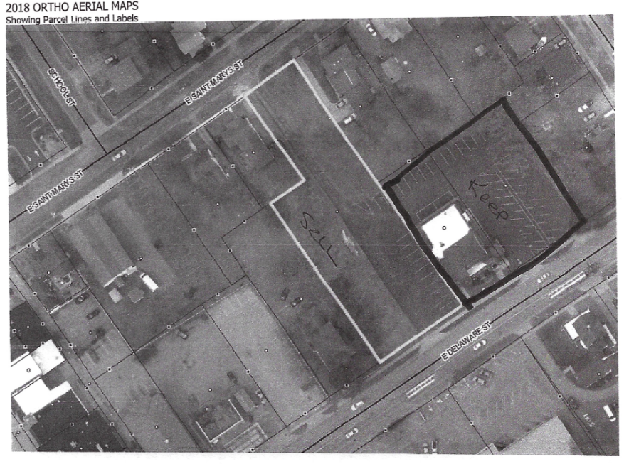

Yours in Christ,
Rev. Katie

Schedule for the Month of May
9 A.M. Sunday School and Coffee w/Katie
10 A.M. SERVICE
MAY 2ND SESSION MEETS
MAY 6TH Pasta Dinner at Holy Family
May 8th MOTHER’S DAY
MAY 15TH FISH FRY BY JOEL AFTER SERVICE
ELVIS AT First Baptist at 3 p.m.
May 17th, FOUNDATION AWARD
May 30th Memorial Day – Office Closed

Worship Volunteers of the Month of May
May 1st Leonda Shroyer May 8th Joe Leary
May 15, Barb Kohl May 22nd Karen Makay
May 29th Amy Druskovich

xxxxxxxxxxxxxxxxxxxxxxxxxxxxxxxxxxxxxxxxxxxxxxxxxxxxxxxxxxxxxxxxxxxxxxxxxxxxxxxxxxxxxxx
Deacon of the Month : Marcia Sikkema
xxxxxxxxxxxxxxxxxxxxxxxxxxxxxxxxxxxxxxxxxxxxxxxxxxxxxxxxxxxxxxxxxxxxxxxxxxxxxxxxxxxxxxx
May Birthdays and Anniversaries

5th Donna Klimczak 27th Mary Fosdick
18th Don & Karolyn Anniversary Colby Spangler
20th Burt & Gloria Anniversary 29th Marcia Sikkema
25th Karen Makay 30th Keith Leighton

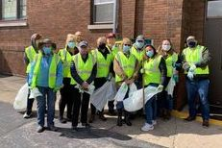
Highway Clean-up May 1st after worship
Following worship we will be picking up trash alongside M-51. All volunteers must be 12 and older. Many hands make light work. Please join us in caring for God’s creation in this small way.

Mother's Day is May 8th this year. A mother is the truest friend we have, when trials heavy and sudden, fall upon us; when adversity takes the place of prosperity; when friends who rejoice with us in our sunshine desert us; when trouble thickens around us, still will she cling to us, and endeavor by her kind precepts and counsels to dissipate the clouds of darkness, and cause peace to return to our hearts. -- Washington Irving

Fifth Sunday of Praise
We will be having a Celebration of Life Service at the VFW on Memorial Day this year, which is May 29th, 2022…It will be held at the VFW. At 2 p.m. If you would like to have a picture and a bit written about your loved one please feel free to contact me, Jan Roeder 423-9777 (note my phone # has changed)
Fish Fry
Because of a mix-up in scheduling the group that we were having on May 15th for our Mother/Daughter/Friend celebration was not able to perform. We decided that it would be good to have the group here in September to kick-off our Fall schedule…Joel has kindly offered to fry fish for us after the service on the 15th …..so as Lori Jerue always says.”It’s all good.”

Soup Supper
I want to thank all who helped with Soup Supper….and those who attended. It was a great night of people working together, laughing, and enjoying other people from our community. This is what Soup Supper is about. See you at the Pasta Dinner ….jmr p.s. We had 107. 20 more dinners sold than the last one we had.

As unto the bow the cord is,
So unto the man is woman.
Though she bends him, she obeys him;
Though she draws him, yet she follows;
Useless each without the other. Longfellow

Highlights of April 11, 2022 Session Meeting.
The meeting was held in person and all elders (Marcia Sikkema excused) and Pastor Katie were present.

Report of Treasurer – Report of Treasurer – there was no report from Fred Reeder.
Quarterly Report as prepared by Missy. Revenues and expenses are both on track with 22% of our budget both collected and spent. This report will be shared with the congregation at the April 24th Meeting.

Old Business
- Land Proposal. There was discussion on the land sale proposal.
- Easter – the Church will be unlocked on Saturday morning so members can drop off flowers for Easter. We will again use the cross display unit.
New Business
- Live Streaming- Pastor Katie is still working with SVT to get a proposal on a better video system.
- Growth Committee (Shannon Allen, Leonda Shroyer and others)
  - Visitor Sunday was March 20. The Congregation was the largest since pre-covid. Some returned the following week.
  - The next Visitor Sunday will be June 5.
  - Next Fellowship meal will be May 15. Joel will do a fish fry. Brian will help him cook.
Report of the Clerk - No report
Communications from Presbytery, Synod or General Assembly
- Presbytery has called a new Stated Clerk/ General Presbyter, Fran Lane-Lawrence, who has been serving as an Interim for the past 18 months or so.
Report of the Moderator/Pastor
- Pastor’s surgery went well, recovery is slower than anticipated. Patience is requested.
Building and Grounds Committee – No report
Memorial and Mission Committee
- One Great Hour of Sharing was dedicated on Palm Sunday. The kids collected $44.47 in their fish banks. The grand total will be reported next month.
- Highway cleanup scheduled for May 1 after church.
- Crop walk April 24 in Paw Paw.
Nominating Committee – No report
Worship and Music Committee
- Amber Nettleton will be preaching May 22.
- May 29 is either Jerry or Janet Duggins
Christian Education and Youth Committee
- The kids did a great job with the Palm Sunday service.
- The Sunday Schoolers requested more crafts and Lauren will see what she can do.
The next Session Meeting on Monday, May 2nd, at 7:00 p.m. at the Church The meeting was adjourned with prayer at 7:50 p.m.
Respectfully submitted,
Karen Makay, Clerk of Session

