Good News Newsletter
First Presbyterian Church of Decatur
June 2022
Katie's Korner
Scott and I are looking forward to having everyone join us for our open house Sunday June, 5 from 2-5pm at the church. Our married life was off to a fantastic start, our wedding was full of our friends and family, joy and laughter. We enjoyed our honeymoon in Cancun, where we visited Chichen Itza, swam in a Cenote (a freshwater cave), and snorkeled in the Atlantic Ocean. We truly enjoyed our time together in such a marvelous place.
Then… we got the call that the ceiling had fallen in at the manse. Luckily, we weren’t home, neither was Ebby, and the roof is still water tight. We’re waiting on insurance and engineer reports to truly assess the damage. It was not the ideal situation to come home to, but I know that we’ll laugh together as we tell our kids about our wedding and honeymoon. There is no other way to describe the events of our lives in the past 2 weeks other than an act of God. By some miracle Scott and I found each other and were joined in marriage surrounded by love. My closest friend, Rev. Jenny Hubbard officiated a beautiful ceremony and spoke of how Scott and I were figuring out life together. Then Scott and I both spoke in our independently written vows, committing to continuing to figure it out together. The theme was clear, God was helping us figure things out. We thought we’d be figuring out how to be married and live together without driving each other nuts. But instead we’re figuring out home repair with our church family. We are truly grateful for your support; it has been a rough week of re-entry but I’m so glad that we all get to figure this out together.
This week we’ll celebrate the wind of the Holy Spirit and the acts of God we experience in our every day lives. May we look for the Spirit to move and blow through the house as we seek to do God’s will.

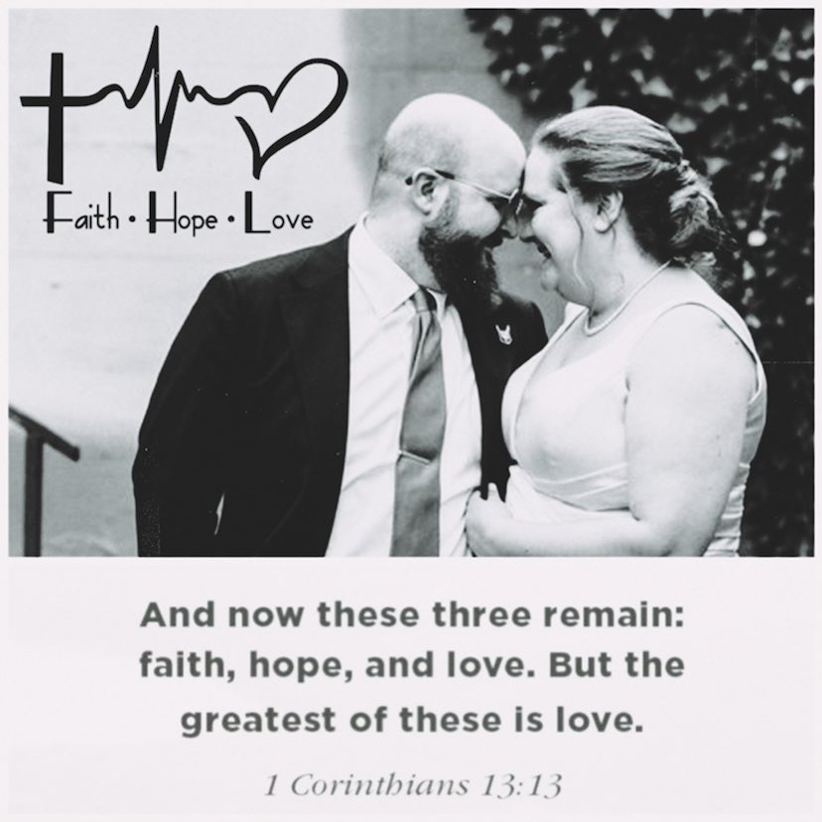

Please join us at our Open House at the Church Sunday, June 5, 2-5pm. In lieu of gifts bring and appetizer to share or make a check out to First Presbyterian Church Wedding Fund to help us make the manse our home.

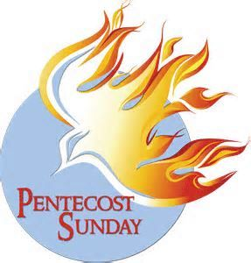
Pentecost is June 5th. Pentecost celebrates the coming of the Holy Spirit 50 days after Easter. Pentecost is the birthday of the Christian church. At Union Church, it’s become our custom to wear red to church to reflect the color of the tongues of fire that symbolize the Holy Spirit. Before Jesus was crucified, he told his disciples that the Holy Spirit would come after him:
“And I will ask the Father, and he will give you another Counselor to be with you forever — the Spirit of truth. The world cannot accept him, because it neither sees him nor knows him. But you know him, for he lives with you and will be in you. I will not leave you as orphans; I will come to you.” John 14:16–18
Also, this Sunday, June 5th, is the 2nd date we choose for “Special Guest Sunday”. We are encouraging all our congregation to invite their friends, family or just make sure to come yourself if you have not been to worship service in a while. We are so incredibly grateful for
your continued support of our weekly worship services as well as being part of our wonderful church family. We love seeing you every week and appreciate your continued support.

As a reminder, the other 2 dates for 2022 for this special day are: Sept 11. & Dec 11.

In Christ's Love,
FPC Growth Committee

Deacon of the Month Karolyn Drenth 423-4841

Monthly Activities at First Presbyterian of Decatur
10 A.M. WORSHIP SERVICE in the sanctuary & on our Facebook page.
June 5 Sunday 2 to 5 Open house at the Church
June 6 Monday 7 p.m. Session Meets
15 Wednesday 5 p.m. PW potluck @ Karen Makays

Liturgists
June 5 Shannon Allen June 12 Jackson Sikkema
June 19 Joan Grosvenor June 26 Barb Kohl

June Birthdays and Anniversaries
13th Glen Pollock 25th Chuck & Pat Anniversary
15th Jan Roeder 26th Blaine Rex
16th Leonda Shroyer 27th Doug Sikkema

4TH Of July Celebrations in Town
THIS YEAR THE FIREWORKS ARE ON THE 3RD. However, the parade and chicken dinner are on the 4th. So please fire-up your ovens and bring some desserts to the VFW for the dinner. Decatur Human Services benefit from the desserts, but they are not doing the dinner.

Presbyterian Women
Praise the Lord and pass the food.
JUNE 15TH. 5 p.m. It is at Karen Makay’s house.
77900 CR 358 South, Decatur. Just go out of town past the VFW…Take the first right turn about 2 miles out of town. Watch for her drive on the left. The house sits way back off the road. You can’t miss it.

Please: If you have any news that you would like to have in next month's newsletter send it on to roederpotluck@comcast.net PLEASE NOTE THAT MY HOME PHONE # IS 423-9777

Highlights of May 2, 2022, Session Meeting.
The stated Session meeting was held in person, all Elders except Connie McIntyre and Marcia Sikkema were present. Pastor Katie Hartwell present.

Report of Treasurer – Report from Fred Reeder.
Change in fund balance – all funds: Beginning Balance $46,549.74
Income $+43,851.48
Expenses $-39,706.92
Liabilities $- 1,339.05
Ending Balance $ 49,355.25
Old Business
- Land Proposal. There was discussion on the land sale proposal.
  - Attorney McNeil will write up the easement.
  - Packet sent to Presbytery for their approval.
New Business
  - Worship Protocols. The offering plate will be moved to the front of the sanctuary.
  - Mother’s Day will be celebrated May 8th.
  - Fish Fry May 15th immediately after service. We will have fish, chicken, coleslaw, and desserts. Joel and Brian (and Davis) will do the cooking.
  - Sunday School recognition will be May 22.
Report of the Clerk
- Prepared the packet for Presbytery.
Communications from Presbytery, Synod or General Assembly
- The next meeting will be June 14th. We will appoint at next meeting.
Report of the Moderator/Pastor
- Vacation for wedding – Amber Nettleton will fill on May 22nd, Jerry Duggan is unable to preach on May 29th, but will send a replacement.
- June 5 will be communion.
- June 5 will be Pastor Katie & Scott’s open house for their wedding.
Endowment Committee – There are 7 applications for scholarships. Joe Leary will present them at the Senior Awards night.
Deacons Report – Nancy Vliek sent Easter, Get Well, Anniversary and thinking of you cards.
Building and Grounds Committee –
- Scott and Katie purchased a new refrigerator for the Manse. The old one still works and is in the garage.
Memorial and Mission Committee
- One Great Hour of Sharing total was $414.47.
- Crop walk April 24 in Paw Paw raised $1,370.
- There were 8 people who participated in the highway cleanup.
- The shelter was given 15 - $5 gift cards.
- Minute for Mission on the Pentecost offering on May 22 and 29
Worship and Music Committee
- Amber Nettleton will be preaching May 22.
- Still need May 29. Jerry Duggins has someone.
Christian Education and Youth Committee
- Recognition of Lauren and Leonda on May 22.
The next Session Meeting will be Monday June 6.
Respectfully submitted, Karen Makay, Clerk of Session.

