Good News Newsletter
First Presbyterian Church of Decatur
July 2020
Katie's Korner
Unfortunately, the days of the Coronavirus are still upon us as we’re seeing more and more cases now that many restrictions have been lifted. Our COVID-19 taskforce has been looking at how we can best return to gathering in person, and we are hoping to make some decisions in this months session meeting. As we consider resuming in person worship, it is important that we take the health and safety of others into account as we resume ‘normal’ activities. One of my favorite weeks of the year is 4th of July, and it’s sad to know that we won’t be able to celebrate with the parade and fireworks like we have in the years past. But things must change for the health and well-being for us all.
Jesus instructs us to care for the most vulnerable in society and he often would stop whatever he was doing to tend to the needs of others. There are many vulnerable people in our community and congregation. In the days of COVID we are forced to think about those who are medically vulnerable, but we cannot forget those among us who are dealing with loneliness, depression, isolation, illness, poverty, racial injustice among many other ills. We are called to support each other and lift one another up in prayer and work to heal our broken world. As we follow Jesus’ teaching and example, may we all consider the needs of those around us, before ourselves. Wear a mask. Call a friend. Stand up to injustice. Love your neighbor as yourself. And I hope we’ll be able to see each other again soon.

Your in Christ,
Rev. Katie
July Birthdays and Anniversaries
1st Rev. Will Christians 19th Jackson Sikkema
2nd Bradley & Hilary Newell 20th Connie Johnson
4th Nell Vliek 27th Katelin Makay
6th Roxanne Lovell Lori Baushke
16th Jack Hovenkamp Eileen Thomas

**********Deacon of the Month is Karolyn Drenth 423-4841**********

Don Reits passed away after a long illness on May 12th. Sadly in these days we have not been able to grieve the way we would like with friends and family. Don will be remembered with his ready smile, and cheerful nature. Memorial contributions can be made to the Decatur Athletic Department or First Presbyterian Church. Our thoughts are with Carolyn, who now lives in Kalamazoo with family.

Bob Krueger was taken away because of an unfortunate accident. His family will miss his feisty nature. A private service will be held July 2nd, with a celebration of his life held at a later date.

If you would like a copy of the Upper Room for July-August delivered to your house, please call or email Rev. Katie and she will drop one off for you.
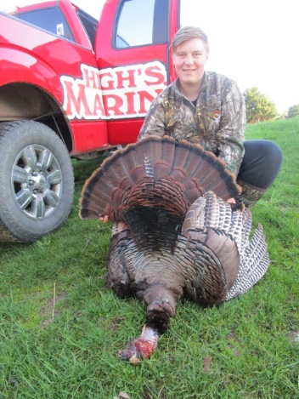
During these times of quarantine and on-line worship, many are missing the social and chitchat parts of our normal church life. It has been nice to see the kids and youth taking part in the on-line services, but in an effort to keep us connected we'll include some news and updates here and on our church Facebook page.
Two of our teens have been enjoying the outdoors the old-fashioned way---hunting and fishing. Davis Klimczak bagged his first-ever turkey, and it was a trophy! Thanks to his confirmation mentor, Joel Shroyer, for sharing his private wildlife preserve!
Abby Baushke is a one-woman fishing phenomenon. She drove the boat, baited the hook, and caught a bucket full of bluegills. And then she cleaned them! (Don't know who fried them, though!)
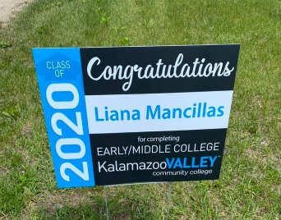
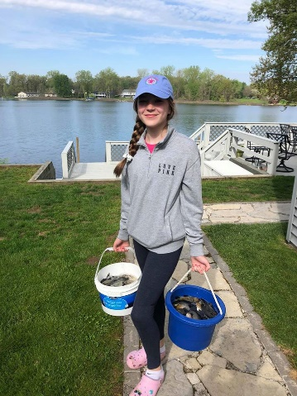
Jackson Sikkema also spent some time in the great outdoors, but it might not have been as exciting, Jackson was part of the strawberry picking crew for Druskovich farms. In the fields by 7 AM, Jackson earned kudos from Doc for being one of the only pickers to show up on a hot rainy day that the other 8 skipped. Starting driver's education this month, Jackson will probably need his farm work money to pay for gasoline!
Liana Mancillas has completed her associate's degree at Kalamazoo Valley and is enrolled at Western Michigan University where she will complete her studies toward a teaching certificate. Liana has moved to an apartment in Kalamazoo.
Congratulations to all!
High School Senior Gifts - This year we handed our Bibles to our graduating Seniors, they were delivered or dropped off. We want to ensure that as they leave High School and begin the next phase of their life, that they are equipped with the Word of God. The Bible we gave them was the CEB Navigation Bible. It’s a study Bible equipped with tools and resources for their own faith exploration. The CEB is a translation from the original biblical languages that is easy to read and understand. We congratulate the graduation class of 2020 and presented these bibles to Jordan Christensen, Regan Rose, Gavin Smith and Colby Spangler.
Decatur Human Services Needs Volunteers
Needed - One or two volunteers to assist at Decatur Human Services Clothing Center to help sort and fold/hang clothing, greet clients and assist them if needed for 3-4 hours per week. Call Melody Soles at 269-568-4510 if interested.

Needed - A volunteer willing to call Senior Citizens (approx. 90) eligible for Sr. Commodities and remind them of pick up dates. Calls need to be made once per month during the 2nd week of each month. Anyone interested in assisting with this project may call Jennie Mahieu at 269-299-0347.

Our next Session Meeting will be Monday, July 5 at 7pm
held in the Sanctuary at church.

Highlights of the June 1, 2020 Session Meeting Minutes
The stated Session meeting of the First Presbyterian Church of Decatur, Michigan was held at 7 PM at the via Zoom due to the Crona-19 virus quarantine. All present except Connie McIntyre could not connect.
Report of Treasurer – There was no report due to the absence of Fred Reeder.
Sailboat Church Discussion – discussed Chapter 5 – Motion to investigate holding a Prayer Vigil with our fellow Decatur Churches.
Old Business
- Small Business loan – We received a request for more information. Hopefully will be complete soon.
New Business
- Discussion on having a parking lot or park “in person” worship service.
- Discussion on having collaborative Worship with Paw Paw a couple of times.
Report of Clerk
- Recorded the death of Don Reits May 12, 2020
- Joel Shroyer elected Commissioner to Zoom Presbytery meeting June 9th
Pastor’s Report
- Keeping connected to members with video chats.
- Attended Festival of Homilies virtually.
Board of Deacons
- The Deacons are each making calls to all members making sure all are ok, as well as sending birthday & anniversary & sympathy cards. Bobbie Rex deacon of the month.
Endowment Committee
- No report
Stewardship, Audit, Personnel Committee
- Today’s bank balance $27,438 at First State, $14,168 at Honor
- Online giving $1,943 for May.

Building and Grounds Committee
- Gutters not yet installed
- Landscape updates have begun
- Fence at manse needs repair
Memorial and Mission Committee
- Memorial gift received from Don Reits family
- Pentecost offering starting. 40% of the proceeds remain in our community.
Worship and Music Committee
- Linda not available June 28th.
Christian Education and Youth Committee
- No report
The next Session Meeting July 6th, 2020 at 7:00 p.m. Place to be determined.

Respectfully Submitted,
Karen Makay, Clerk of Session

